Association of Innovative Entrepreneurship CR

in cooperation with

Ministry of Education, Youth and Sports,
Ministry of Industry and Trade,
Committee of National Economy, Agriculture and Transport of
the Senate of the Parliament CR, and
Domestic and Foreign Members and Partners of AIE CR

is organising

- XXIII International Symposium INNOVATION 2016

- XXIII International Fair of Inventions and Innovation

- XXI Innovation Award of the Year 2016
under the patronage of H. E. Miloš Zeman, President of the Czech Republic

Date

December 6 – 9, 2016

Venue

The Czech Association of Scientific and Technical Societies
Novotného lávka 5, Prague 1
Hotel International Prague
Koulova 15, Prague 6
The Senate of the Parliament of the Czech Republic
Valdštejnská 4, Prague 1

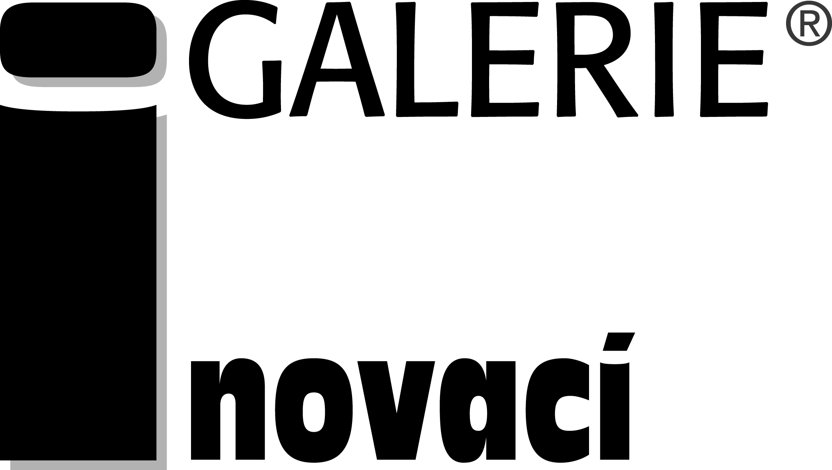

Professional responsibility
Association of Innovative Entrepreneurship CR

Programme and Organising Committee
Vladimír Gašpar Czech Association of Development Agencies
Miroslav Hájek Czech University of Life Sciences Prague
Petr Hladík Technology Centre of the CAS
Josef Janda Ministry of Education, Youth and Sports
Petr Křenek Institute of Plasma Physics AS CR, v.v.i.
Iveta Němečková Association of Innovative Entrepreneurship CR
Martin Štícha Office of the Government of the Czech Republic
Pavel Švejda, chairman Association of Innovative Entrepreneurship CR
Zora Vidovencová Czech Association of Scientific and Technical Societies
Štefan Zajac Council of Scientific Societies CR
Karel Žebrakovský Czech Technical University in Prague

Overview of previous INNOVATION events
INNOVATION ` 94 December 6 - 8, 1994 Faculty of Physical Education and
Sport of the Charles University, Prague 6
INNOVATION ` 95 December 5 - 7, 1995 Faculty of Mechanical Engineering of the
Czech Technical University, Prague 6
INNOVATION ` 96 December 3 - 11, 1996 National Technical Museum (NTM), Prague 7

INNOVATION ` 97 December 2 – 10, 1997 NTM, Prague 7

INNOVATION ` 98 December 1 – 9, 1998 NTM, Prague 7

INNOVATION ` 99 December 7 – 9, 1999 Czech Association of Scientific and Technical Societies (CASTS), Prague 1
INNOVATION 2000 December 5 – 9, 2000 CASTS, Prague 1
INNOVATION 2001 December 4 - 10, 2001 CASTS, Prague 1
INNOVATION 2002 December 3 - 6, 2002 CASTS, Prague 1
INNOVATION 2003 December 2 - 5, 2003 CASTS, Prague 1
INNOVATION 2004 November 30 - December 3, 2004
CASTS, Prague 1
INNOVATION 2005 November 29 - December 2, 2005
CASTS, Prague 1
INNOVATION 2006 December 5 – 8, 2006 CASTS, Prague 1
INNOVATION 2007 December 4 – 7, 2007 CASTS, Prague 1
INNOVATION 2008 December 2 – 5, 2008 Senate of the Parliament of the Czech Republic (SPCR); Academy of Sciences CR, Prague 1; CASTS, Prague 1
INNOVATION 2009 December 1 - 4, 2009 SPCR, Prague 1; TIC ČKD Prague 9; CASTS, Prague 1
INNOVATION 2010 November 30 – December 3, 2010
SPCR, Prague 1; CASTS, Prague 1; Crowne Plaza Hotel, Prague 6
INNOVATION 2011 December 6 - 9, 2011 SPCR, Prague 1; CC CITY, Prague 4; CASTS, Prague 1
INNOVATION 2012 December 4 - 7, 2012 SPCR, Prague 1; CASTS, Prague 1
INNOVATION 2013 December 3 – 6, 2013 SPCR, Prague 1; CASTS, Prague 1;
KC U Hájků, Prague 1
INNOVATION 2014 December 2 – 5, 2014 SPCR, Prague 1; CASTS, Prague 1;
Technology Centre of the CAS (TC CAS), Prague 6
INNOVATION 2015 December 1 – 4, 2015 SPCR, Prague 1; CASTS, Prague 1;
TC CAS, Prague 6

PROGRAMME OF THE WEEK OF RESEARCH, DEVELOPMENT
AND INNOVATION IN THE CZECH REPUBLIC

XXIII International Symposium INNOVATION 2016
- Plenary Session - Innovation potential of the Czech Republic, December 6, 2016

  - Exhibition opening, performance of Vocalica chamber choir, meeting exhibitors and participants of the INNOVATION 2016 (participation by invitation only), December 6, 2016

- Section Technology Transfer, December 7, 2016

  - Section International Cooperation in Research and Innovation - EUREKA and Eurostars Programme, December 8, 2016

- Official announcement of Visionaries 2016 Award results (participation by invitation only), December 8, 2016

XXIII International Fair of Inventions and Innovation, December 6 - 9, 2016
- Exhibition Section

- Presentation of exhibitors
- Innovation products submitted for the Innovation of the Year 2016 Award

XXI Innovation Award of the Year 2016
- Held under the patronage of H. E. Miloš Zeman, President of the Czech Republic

- Eligibility criteria of competition and instructions for fulfilling Application Form are available on AIE CR website http://www.aipcr.cz
  - Deadline for submitting applications is on October 30, 2016 and doing fully recommended consultation till October 17, 2016

- Official announcement of results and Innovation Award ceremony on December 9, 2016

Information centre INNOVATION 2016
- Actual information about the INNOVATION 2016 is available on website http://www.aipcr.cz/eng/default.asp

GENERAL INFORMATION

* Official languages
Czech and English languages (no simultaneous translation is provided).

* Registration of participants
Registration will be organized daily prior to the opening of each INNOVATION 2016 session – see below time schedule of each session.

* Technical facilities
Laptop and Internet connection will be available.

* Papers of lectures
The papers of selected lectures will be published in the journal Inovační podnikání & Transfer technologií, issue 4/2016 (deadline for papers submission: October 19, 2016).

Some other presentations will be published in the journal Inovační podnikání & Transfer technologií, issue 1/2017 (deadline for papers submission: February 8, 2017).

Information about the Symposium and discussion summary of all sections will be published on website http://www.aipcr.cz

* Accommodation
The organisers of the INNOVATION 2016 don´t organise accommodation for participants of the Week of Research, Development and Innovation in the Czech Republic event.

* Refreshment
Refreshment will be provided during sessions of the INNOVATION 2016 at meeting premises.

* Conference fee
Free participation is in all sections of the INNOVATION 2016 and visiting the Exhibition section.

* Fee of exhibition space
Fee of one exhibition space with accessories (e. g. stand for information materials, table) including roll-up placement is CZK 2 000,-
Fee of roll-up placement only is CZK 1 000,- throughout the duration of the Exhibition section of the INNOVATION 2016.
(Members of AIE CR pay one half of exhibition space costs).

Participants and exhibitors of the INNOVATION 2016 may use services of the Information Centre INNOVATION 2016. This Help desk is located in the room B 142 (the 1st floor of the CASTS building).

* Insurance
The organizer will not provide insurance of roll-ups, exhibits and other equipment of exhibitors.

* Registration for INNOVATION 2016
Registration Forms are to be sent by ordinary post to Association of Innovative Entrepreneurship CR, attn. INNOVATION 2016 (address: Novotného lávka 5, CZ-116 68 Prague 1, Czech Republic), and/or by e-mail to email address: nemeckova@aipcr.cz

Confirmation of participation will not be acknowledged. A notice to the participants will be only sent if registration has reached full capacity and due to this reason is closed.

DEADLINES FOR SUBMITTING APPLICATIONS
- Participation in the Symposium sessions November 30, 2016
(in the Application Form is necessary to indicate session)

- Participation in the Fair of Inventions and Innovation November 14, 2016
(a short written information about exhibitor is necessary to provide; max. 6 lines in Czech language as well as in English language including contact address)

- Application for the Innovation of the Year 2016 Award October 31, 2016
- fully recommended consultation till October 17, 2016

- Application Forms and other instructions are available on website http://www.aipcr.cz

XXIII International Symposium INNOVATION 2016

Plenary session

Innovation Potential of the Czech Republic

Venue:
Conference room No. 418 (4th floor)
CASTS building, Novotného lávka 5, Prague 1

Tuesday December 6, 2016

Moderator: Petr Křenek, Institute of Plasma Physics ASCR, v.v.i.

09.30 – 10.00 Registration

10.00 – 10.20
Opening of the INNOVATION 2016: The twenty-third event edition
System of Innovative Entrepreneurship in the Czech Republic
Pavel Švejda, Chairman of the Programme and Organising Committee INNOVATION 2016

10.20 – 10.40
Innovation as an integral part of the programmes financed by the EF
Dagmar Vránová, Ministry of Regional Development of the Czech Republic

10.40 – 11.00
INTER-Excellence programme
Jiří Burgstaller, Ministry of Education, Youth and sports of the Czech Republic

11.00 – 11.40
Tasks of Economic Diplomacy to 2020
Martin Tlapa, Ministry of Foreign Affairs of the Czech Republic

11.40 – 12.00
EUREKA Cluster projects and their role for European innovations
Jacques Magen, CELTIC Plus

12.00 – 12.20
Experiences of STP Žilina from cooperation with STPs in the Czech Republic and other countries
Juraj Kavecký, Science and Technology Park Žilina

12.20 – 12.40
Tasks of Technology Agency CR in the field of applied research
(Signing Memorandum of Cooperation between AIE CR and TA CR)
Petr Očko, Technology Agency CR

12.40 – 13.00 Coffee break and small refreshment

13.00 – 13.20
LE 15028 project (Professional contact organizations for EUREKA and Eurostars programme)
Svatopluk Halada, Association of Innovative Entrepreneurship CR

13.20 – 13.40
LE 15014 project (OKO SVTP CR) and SPINNET (SPolupráce, INovace, NETworking) project
Pavel Švejda, Science and Technology Parks Association CR

13.40 – 14.00
Services of Enterprise Europe Network aimed for Technology transfer
Petr Hladík, Technology Centre CAS

14.00 – 14.20
Projects of CzechInno z.s.p.o.
David Kratochvíl, CzechInno, z.s.p.o.

14.20 – 15.00
Salute of selected foreign participants

15.00 – 15.30
Discussion
Moderated by Petr Křenek

15.30
Conclusions of the Plenary session
Pavel Švejda

x x x x x

16.00
Official opening of the Exhibition section INNOVATION 2016
CASTS building, 4th floor, Novotného lávka 5, Prague 1

17.30
Performance of Vocalica chamber choir
CASTS building, ground floor, Novotného lávka 5, Prague 1

18.00
Meeting of participants and exhibitors of the INNOVATION 2016
CASTS building, Klub techniků, 1st floor, Novotného lávka 5, Prague 1
(participation by invitation only )
x x x x x

XXIII International Symposium INNOVATION 2016



Financial instruments for the development of small and medium businesses - loans, guarantees and venture capital

Registration for workshop via e-mail address: info.een@tc.cz

Venue:
Hotel International Prague, Koulova 15, Prague 6

Wednesday, December 7, 2016

Moderator: Petr Hladík, Technology Centre of the CAS

9.30 – 10.00 Registration

10.00 – 10.10
Opening
Petr Hladík, Technology Centre of the CAS, Enterprise Europe Network CR

10.10 – 11.00
Financing innovation by European financial institutions EIB, EIF and tools to support small and medium-sized companies - InnovFin
Hana Nylander Kaloudová, EIB

11.00 - 11.30
InnovFin - providing credit for innovative projects of small and medium-sized companies and success stories
Ladislav Dvořák, Česká spořitelna, a.s.

11.30 - 12.00
Profi Loan START - financing beginning entrepreneurs with warranty
Jan Hanuš, KB EU Point, Komerční banka, a.s.

12.00 – 12.50 Lunch break

12.50 - 13.10
ZÁRUKA programme - guarantees for loans for small and medium businesses Michal Pluta, Českomoravská záruční a rozvojová banka, a.s.
13.10 – 13.30
Funding support of breakthrough innovations in phase III of the H2020 SME Instrument
Jiří Vavřínek, Technology Centre of the CAS, Enterprise Europe Network

13.30 – 13.50
Financing start-ups with support from business angels
Gabriel Berdár

13.50 – 14.10
How to finance development of the company by capital entry of the investor?
Jiří Beneš, 3TS CAPITAL PARTNERS

14.10 – 14.30
Crowd funding - alternative financing B2C business
Andrea Lauren, Fundlift

14.30
Refreshment and Networking

x x x x x

Individual visit to the Exhibition section INNOVATION 2016
CASTS building, ground floor, 1st – 4th floors, Novotného lávka 5, Prague 1

XXIII International Symposium INNOVATION 2016

International Cooperation in Research and Innovation
EUREKA and Eurostars Programme

Venue:
Conference room No. 418 (4th floor)
CASTS building, Novotného lávka 5, Prague 1

Thursday December 8, 2016

Moderator: Svatopluk Halada, Association of Innovative Entrepreneurship CR

9.30 - 10.00
Registration and Coffee
10.00 -10.10
EUREKA in the European Research Area
Svatopluk Halada, Association of Innovative Entrepreneurship CR

10.10 - 10.50
EUREKA Cluster projects – their strategy, goals and results
Peter Hermann, CELTIC-Plus Cluster, CELTIC Office
Marek Valdmann, EURIPIDES-2 Cluster, BIC Ostrava s.r.o.
10.50 - 11.30
EUREKA in Austria and Germany – support services to national companies and research organisations, success stories of EUREKA projects
Irina Slosar, EUREKA NPC for Austria, FFG, EUREKA-Eurostars national secretariat
Katharina Lehmeier, EUREKA project manager, DLR, EUREKA-COST Bureau
11.30 - 11.50
Current support of EUREKA and Eurostars programme in the Czech Republic
Karel Šperlink, EUREKA HLR for the Czech Republic, Association of Innovative Entrepreneurship CR
Josef Martinec, EUREKA NPC for the Czech Republic, Ministry of Education, Youth and Sports

11.50 - 12.30
Presentations of successful EUREKA and Eurostars projects with Czech participation
Czech project participants

12.30 - 12.50
Questions and Answers
Svatopluk Halada

12.50 - 13.00
Conclusions and recommendations
Peter Hermann and Karel Šperlink
x x x x x

13.00 – 15.00
Presentations of foreign participants

x x x x x

Individual visit to the Exhibition section INNOVATION 2016
CASTS building, ground floor, 1st – 4th floors, Novotného lávka 5, Prague 1

Selected success stories of EUREKA and Eurostars projects and their results will be presented in the Exhibition section INNOVATION 2016.

x x x x x

19.00
Official announcement of Visionaries 2016 Award results
(participation by invitation only)

XXIII International Symposium INNOVATION 2016

Announcement of the Innovation Award of the Year 2016

Main Hall of the Senate of the Parliament CR, Wallenstein Palace, Prague 1

Friday, December 9, 2016
10.00 - 12.00
Presentations of innovative products submitted for the XXI Annual Competition of the Innovation Award of the Year 2016

Award ceremony

Participation by invitation of the Senate of the Parliament CR and Association of Innovative Entrepreneurship CR

12.00 - 13.00
Press conference

Reception

13.00 - 15.00
Session of the AIE CR bodies
(participation of members of AIE CR only)

