Waste Water Treatment Against Pesticides and Petroleum Products
D. Grinshpan, A. Zyhmant, S. Makarevitch, N. Tsygankova, T. Savitskaya
Belarusian State University, Belarus, Minsk
e-mail: grinshpan@bsu.by

Waste water treatment is becoming even more critical due to diminishing water resources, increasing waste-water disposal costs, and stricter discharge regulations that have lowered permissible contaminant levels in waste streams. The ultimate goal of waste-water management is the protection of the environment in a manner commensurate with public health and socio-economic concerns. The conventional waste water treatment procedure may include processes such as settlement, coagulation, flocculation, media filtration to remove colloidal and suspended solids and finish filtration, e.g. membrane process in some cases.
Besides the aforesaid, adsorption on the activated carbon is used as a process for the removal of the organic nature contaminants. Activated carbons ability to remove a large variety of compounds from contaminated waters has led to its increased use in the last thirty years. Recent changes in water discharge standards regarding toxic pollutants has placed additional emphasis on this technology.
High effective sorbent on the base of modified activated carbon with high water affinity has been developed in the Scientific Research Institute for Physical and Chemical Problems. The main feature of this sorbent is the capacity for a quick spontaneous dispersion in water with the formation of stable dispersion with the narrow distribution of the particles by size. It has plenty of particles with the colloid degree of dispersity. As a result high specific dispersion surface is achieved that provides high adsorption capacity and hence the effective removal of dissolved pollutants from water. But the use of this sorbent is complicated by the filtration issues of the fine dispersion. The tapping of the coagulants improves the situation.
The conventional inorganic coagulants may be considered as less efficient when compared to the organic polymers (flocculants) regarding their aggregation or sorption abilities. In order to increase water treatment efficiency, the combination of sorbent, inorganic coagulant and polyelectrolyte flocculant in one and the same composite reagent is proposed. Composite reagents for natural and waste water treatment contain in their composition a coagulant, flocculant and sorbent. When composite reagent contains polymeric flocculants their chemical and granulometric properties were found to determine composite reagents efficiency. Figure 1 demonstrates the particles size distribution for composite reagent. Dispersity of the reagents provides a different dissolution rate of mixture components. Firstly the sorption with activated carbon takes place, then the coagulant dissolves and hydrolysis process is beginning. A flocculant is a substance with polymer nature, so it dissolves later and facilitates forming large particles. Additional cost benefits of composite reagents include the avoidance of specific equipment for handling the polyelectrolyte flocculant (dissolution, storage, pumping systems) and reducing coagulant dosage.
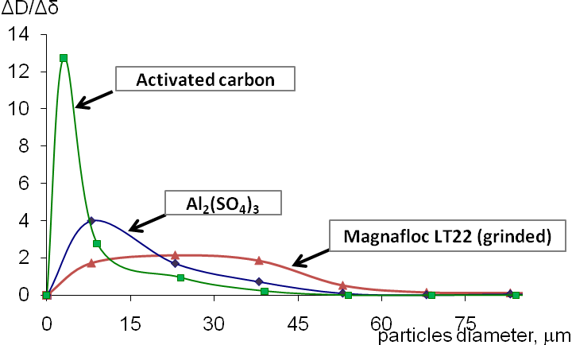
Fig. 1 - Particles size distribution for composite reagent

The results of the waste water treatment against some pesticides are listed in the Table 1.
Oil spills are a global concern due to the environmental and economical impact. One of the most economical and efficient means for the removal of spilled oil from water surface is the use of sorbents. Natural organic sorbents as the environmentally friendly products have some advantages in the comparison with the natural inorganic and synthetic sorbents.

Table 1 - Pesticides removal from waste water
Pesticide | Initial concentration, mg/dm³ | Final concentration, mg/dm³ | MPC, mg/dm³ | Removal efficiency, %
Acetochlor | 155,0 | 0,06 | 0,003 | 99,7
Isoproturon | 26,8 | 0,019 | 0,09 | 99,9
Ethofumesate | 0,160 | N.D. | 0,5 | 100,0
Metazachlor | 12,4 | N.D. | 0,002 | 100,0
Propiconazole | 387,7 | 0,022 | 0,15 | 100,0
Diflufenican | 14,1 | N.D. | 0,15 | 100,0
Metamitron | 7,50 | N.D. | 0,3 | 100,0
New hydrophobized powdered sorbent “Lignosorb” on the basis of the hydrolytic lignin has been developed at the Belarusian State University. Hydrolytic lignin is a commercial waste product of wood conversion to ethanol. Lignosorb is a deep brown powder with bulk density no more than 350 kg/m³. The particles diameter is 0,25-0,8 mm. sorbent specific surface value estimated by the nitrogen adsorption method is 3-20 m²/g. Total pores volume is 4-7 m³/g. The adsorption capacity for different oil products depending on the temperature, water content and lignin particle size have been studied for Lignosorb and known oil sorbents. The oil adsorption capacity of Lignosorb is 2,8 g/g. Lignosorb thanks to the rather high bulk density can be applied to the oil spills manually or mechanically by the conventional sprayers. It doesn’t sink after the oil adsorption during more than a month. Lignosorb transforms liquid oil to the solid product. It is easy to collect from the surface of the water. The rheological properties of the suspensions of Lignosorb in oil products at different sorbent to oil ratio have been examined. Saturated by different oil products Lignosorb can be easily granulated and utilized as a fuel in the co-firing regime. It has the higher heating value of 32,1-38,8 MJ/kg while the coal has 20,9-30,1 MJ/kg. Fuel pellets are very attractive to use at small productions and farms.

