New Green Process for the Regenerated Cellulose Fibre Production
D. Grinshpan, A. Hanchar, N. Tsygankova, S. Makarevich, T. Savitskaya
Belarusian State University, Belarus, Minsk
e-mail: grinshpan@bsu.by

Cellulose is the most abundant renewable biopolymer on Earth. Because of cellulose can’t be melted without degradation, the processing of cellulose into fibres requires either derivatization or dissolution into a direct solvent.
The group of the regenerated cellulose fibres covers cupric fibres, viscose fibres, and saponified acetate fibres.The most widely used regeneration method is called the xanthate process or viscose process. Nevertheless, it is concerned to be the most harmful in the chemical fibre industry.
In the past century, although new direct solvent systems were found, e.g. liquid ammonia/ammonium thiocyanate, methal thiocyanate salts, zink chloride, lithium chloride/ N,N-dimethylacatamide and N,N-dimethyl sulphoxide, NaOH/thiourea, ionic liquids and others [1], still most of these systems were limited to laboratory scale applications. Being investigated to some extent, they are at a distance from the finish today. In recent years, only the Lyocell process based on N-methyl-morpholine-N-oxide (NMMO) can be counted as the viable industrial scale alternative to the viscose process. However, it still has many environmental issues that include the minimization of several side reactions, further reduction of undesired byproducts and efficient recovery of the expensive solvent [2].
Currently much attention of researchers has been devoted to obtain highly concentrated cellulose solutions in anhydrous superphosphoric acids [3]. But the fibre prossesing requires an acetone coagulation bath, which is hardly possible to implement on a large scale due to the flammability of acetone.
New concept and “green” approach for dissolution of cellulose have been proposed as a quite real alternative to the viscose process at the Belarusian state university. Fibre production processes have been implemented in the laboratory and pilot scales. According to the novel process the aqueous solutions of orthophosphoric acid can be used as the efficient solvents for cellulose, and aqueous solutions of isopropyl alcohol can be used as the coagulation baths. In fact, two of the basic principles of “green chemistry” are to develop the process. They include the use of renewable raw material and the cut of water consumption.
Orthophosphoric acid aqueous solution is a non-volatile and low-toxic solvent; dissolution of cellulose occurs very quickly (within 1-3 hours); cellulose solutions in orthophosphoric acid as opposed to the alkali solution are not sensitive to oxygen or light. As the alternative to the rayon process novel process distinguishes by its environmentally friendly matter and closed technological cycle (see Figure 1). Almost completely regenerated solvent makes its possible to eliminate sewage pollution of the environment. The reuse of solvent and other components of the regenerable process has been achieved by the distillation of the coagulation baths. The main features of the novel process are lack of sewage contaminating reservoirs and low water consumption (less than 16 m³ of water per 1 ton of fibre).
Cellulose
Activation,
Dissolution,
Deaeration
H₃PO₄
H₂O
Filtration
Molding

Distillation
Drying
Fibre
IPA

Figure 1. The basic flow diagram of closed technological cycle of fibre production

The optimum regime for highly concentrated spinning solutions of cellulose (7-9 wt. %) with minimal polymer degradation (on the extruded samples the degree of polymerization is 400-600) has been determined. The dissolution time does not exceed 3 hours.
We have registered for the first time an unusual rheological behavior of concentrated solutions of cellulose in aqueous orthophosphoric acid. Rheological investigations of 7–9% solutions of cotton cellulose and its joint solutions with chitosan, polyvinyl alcohol, and polyacrylonitrile that are suitable for use as spinning solutions to form mercerized cellulose fibres [4].
It has been found that the rheological behavior of the concentrated cellulose solutions in orthophosphoric acid considerably differs from pseudo plastic behavior [4]. With increasing shear stress the intermediate part of the flow curve remains on a quasi-Newtonian plateau of viscosity. It has been explained in terms of shear-induced anisotropy. The small contents of polymers such as chytosan, polyacrylonitrile and others being added to the cellulose solution strongly influence the profile of viscosity curves.
A pilot plant machine for fibres spinning from polymer solutions has been developed. The 4 dm³ capacity machine reservoir allow to spin a continuous or periodic mode. The fibre tensile strength (22-28 cN/tex), and the fibre elongation at break (10-25%) have been tested. The modulus of elasticity (600-1000 cN/tex) is far exceeded the one of conventional viscose fibres, cotton and wool. Figure 2 shows scanning electron microscopy (SEM) images of the surface (left) and cross-section (right) of novel cellulose multi-filaments. Composite fibres containing chitosan demonstrate the unusual increasing of flame resistance: the oxygen index of cellulose-chytosan fibres is 28-57 % in the comparison with the pure cellulose flame resistant fibres (25-28%).
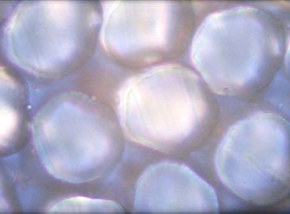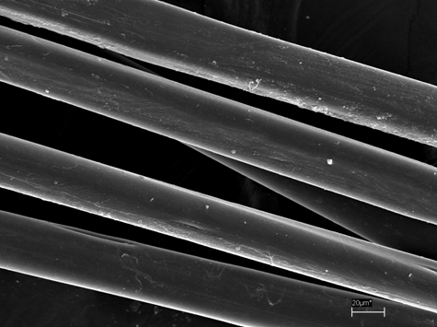
Figure 2. A bundle of filaments have been observed by using optical microscopy (right) and by using SEM (left)

The common name (Greencel) is suggested to fibers and yarns produced by the new technology, which reflects the fact that it is produced through an environmentally-friendly process and its compliance with the principles of the modern development of new technologies, i.e. the principles of "green" chemistry.

1. Production, Chemistry and Properties of Cellulose-Based Materials (ed D.Plackett), J. Wiley&Sons, UK 2011.
2. Regenerated Cellulose Fibres (Ed: C. Woodings),Woodhead Publishing,Cambridge, England 2001.
3. Boerstoel H.; Polymer. 42 (2001) 7371-7379
4. Grinshpan, D.; J. Eng. Phys. Thermophys. 84 (2011) 594-598

