International Exhibition Activity

of the Ministry of Education of the Republic of Belarus

T. Malyshka, G. Senchenko

State Enterprise «Scientific and Technological Park BNTU "Polytechnic»
e-mail: senchenko@icm.by

Republican Innovative Unitary Enterprise "Scientific and Technological Park BNTU "Polytechnic" (hereinafter "Polytechnic") is a leading innovative company in the Ministry of education system. Since the foundation "Polytechnic" is actively engaged in the development of innovative entrepreneurship and innovation infrastructure in the Belarusian National Technical University (BNTU) and in the Higher School system of the Ministry of Education: Interuniversity R&D Marketing Center (ICMSRW) is established and functioning for information collecting, analyzing and sharing, for innovative structures and small businesses support.
One of the activities of "Polytechnic" and ICMSRW is active participation in the international scientific and technological exhibitions and fairs through the organization of collective expositions of the Ministry of Education of the Republic of Belarus (MoE). For many years (since 2001), "Polytechnic" annually organizes collective MoE's expositions on innovative developments of Belarusian institutions and innovative enterprises of higher education participating at 20-30 international exhibitions and fairs in many countries in Europe, Asia and Africa. Lack of development of scientific and technical products' market doesn't provide full impact from scientific advances, resulting in unrealized prospective scientific developments [1, c. 114]. An important tool in the task of marketing support for the new products is the international exhibitions.
Participation in exhibitions with proper preparation and well-intensive work during all days of the exhibition can give a good economic effect. At the current stage of business development there is a necessity to increase the economic impact from the exhibition industry [2].
Based on the above, we can determine the high relevance of the Concept development of the participation of MoE's universities and research organizations in the international exhibitions. The Concept was designed to provide a comprehensive approach to the problem solving, to increase the efficiency of decision-making at the appropriate management level of the MoE and at the individual university level or developer, to facilitate the competitiveness of domestic products, the export of high technology products and expansion of innovation activity in the country. The plan of preparation and participation in the exhibition was proposed in the framework of the Concept.
The main problems addressed by the Concept are the following:
- study of the participation results of universities and research organizations of the MoE in the international exhibitions;
- increase in efficiency of R&D results presentation at the expositions;
- competitiveness research of the developments of the universities and research organizations of the MoE on the international market;
- improving the exhibition activity technology;
- improving the information support of the exhibition activity;
- development of objectives, principles and methods of participation in international exhibitions;
- transformation of the international exhibitions in effective marketing tool of scientific and technical products;
- usage of analysis of the international exhibition industry as an important indicator for prospective research directions identifying.
To improve the efficiency of innovation and exhibition activity in the MoE the ICMSRW operates in the following areas:
  - organization of the MoE's expositions and participation in international exhibitions with a collective stand;
  - preparation of the brochures including translation into foreign languages;
  - design layout, offset printing of hand-outs, preparation of samples;
  - media presentations creation;
  - preparation of the tablets and other illustrative materials;
  - organization of the developers' business trips in order to participate in the exhibitions;
  - work on the organization and continued monitoring of participation in the trade fairs of the universities and their results.
Over many years of exhibition activity the "Polytechnic" gained enough experience in various classes and categories of exhibitions: universal industrial fairs, specialized exhibitions, national exhibitions of the Republic of Belarus, as evidenced by the chart in Figure 1.
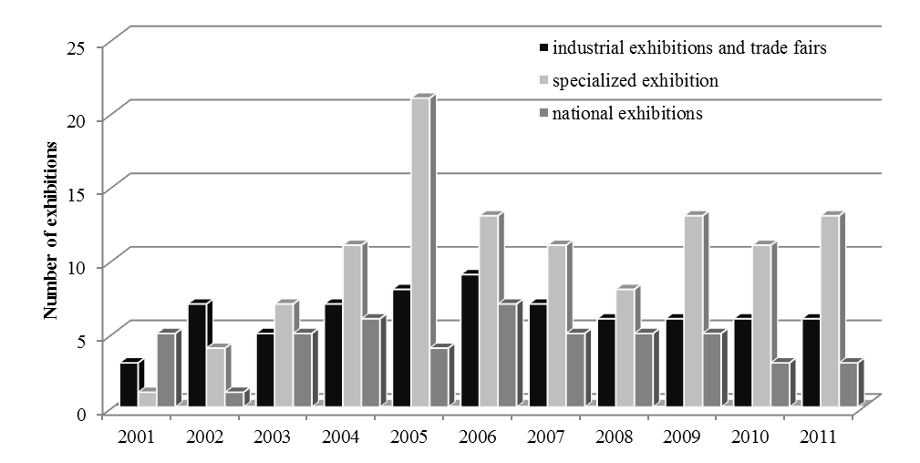
Figure 1 – Participation of the MoE's organizations in the trade fairs
depending on the type of event

Initially we were focused on the major industrial exhibitions and trade fairs in the regions perspective for the development of the economic relations of the republic (neighboring countries: Russia, Ukraine, Poland, Latvia, Lithuania and Germany). National exhibitions of the Republic of Belarus were also actively developed and became one of the most important instruments of production demonstration of economic and innovative potential of the country, promoting and supporting the interests of domestic exporters in the foreign markets. Taking into account the priorities of the state policy in the sphere of foreign economic and trade national exhibitions were organized and conducted in India, Korea, Lithuania, Latvia, Poland and also in еру CIS countries: Russia, Ukraine, Kazakhstan, Armenia, Uzbekistan, Azerbaijan, Turkmenistan. Participation in such exhibitions allowed the exhibitors to introduce their products, technologies, specific proposals, projects and services to the potential partners and potential customers.
As a result of the continuous monitoring of the exhibition effectiveness at the end of the decade the Ministry of Education has taken an active part in specialized exhibitions which are usually held in the format of business-to-business, provide an opportunity to show achievements of the enterprise in a particular industry and to get knowledge about the achievements of other organizations.
On the effective participation of the universities in each of the above groups the universal industrial fairs can be distinguished. Obviously, participation in such exhibitions (including multidisciplinary and multidirectional research activity of the universities of the country) is reasonable and appropriate. A typical example is the Hanover Messe, held annually in Germany, is one of the largest high technology exhibitions in the world. Due to its concept the Hannover Messe from year to year provides various industries entrepreneurs with a unique opportunity to establish international contacts and cooperation, investment and market expansion not only in Germany but also with other countries.
The second group (specialized trade fairs) in the number of contacts inferiors to the first group but in the final analysis on the financial performance may exceed it: these exhibitions are visited by a certain group of visitors with the specific tasks and if the client meets with their task at the show the probability of interest and even contract or any agreement is very high.
The third group (national exhibitions of the Republic of Belarus) in the terms of performance is at the lowest level. But taking into account the necessity to participate in these fairs it should be more careful approach to their preparation and organization: the constant communication with the embassy, the preparation of thematic seminars with entrepreneurs and representatives of the companies providing advertising in the country of the exhibition.
Participation of the Belarusian universities in international exhibitions and fairs is conducting by the organization with ICMSRW the Ministry of Education expositions in the frameworks of the collective stand of the State Committee for Science and Technologies of the Republic of Belarus: for the period 2001-2010 the developments of the universities were represented at more than 200 exhibitions in 30 different countries (see the Figures 2-4).
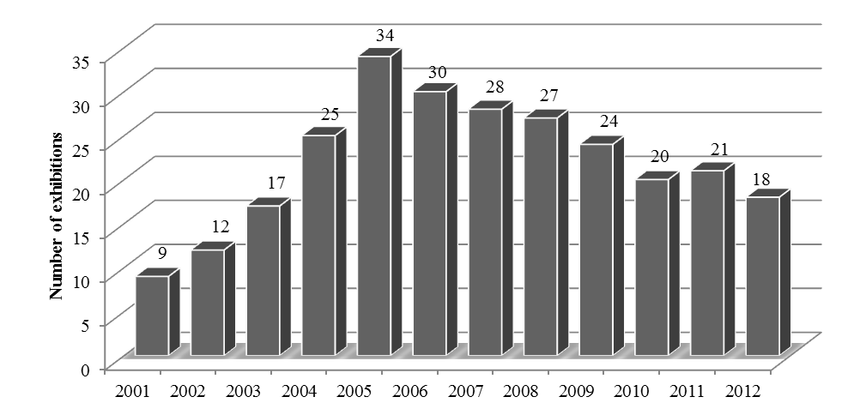

Figure 2 – The universities participation in the exhibitions

over the period 2001-2010
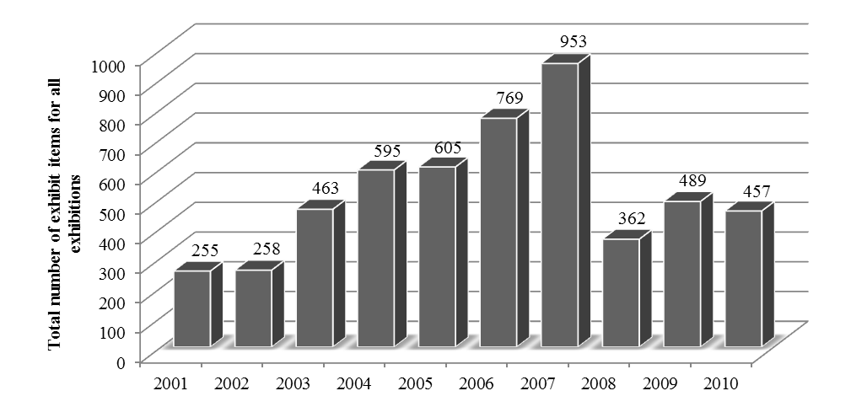

Figure 3 – The total number of exhibit items for all exhibitions
At the initial stage the steady growth was in the number of the trade fairs and presented exhibits (Fig. 2, 3). However, the quantitative growth of participation in exhibitions didn't caused the automatic increase in the effectiveness of this participation as evidenced by the number of the contacts (Fig. 4): in 2008-2010 it has increased despite the overall decrease in the number of exhibitions and presented exhibits.
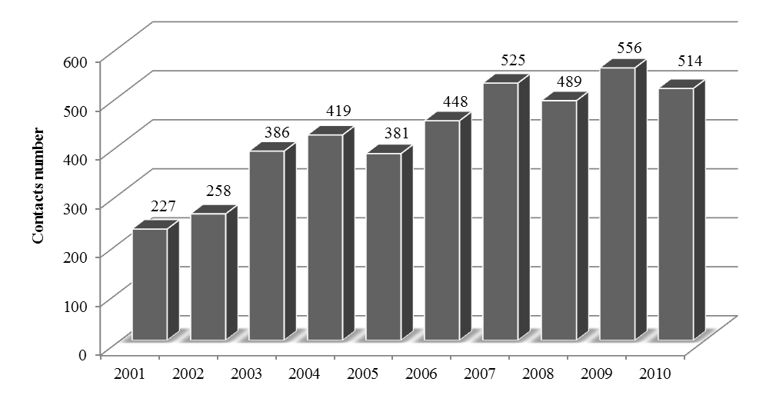
Figure 4 – The number of contacts at the exhibitions for the period 2001-2010
This was, firstly, due to the work on the exhibits classification with the release of the most important and interesting fields, the usage of technical facilities of displaying the visual information and developments presentations and, secondly, due to the establishment of the optimal ratio between the number of fairs and the potential of universities to ensure the expositions with the existing exhibit items (20-25 exhibitions per year).
Regional division of the exhibitions and fairs is very important (Fig. 5, 6).
The Innovation Policy Concept determines the most important socio-economic objective – the improvement of the scientific research implementation efficiency in domestic production. Therefore, the regional division of the exhibitions is objective: the leading region is the national market. It should be noted that this is mainly specialized exhibitions. Regular collective stands of the Ministry of Education are represented in the CIS countries and neighboring states as determined by the Belarusian economy focused largely on the countries of the former Soviet Union. The trend over the last decade shows the growth of foreign trade geography. However, the share of the CIS countries in total, though reduced, however, actually has a decisive influence on the processes in Belarus (especially, true for Russia which is one of the major trading partners of the country).
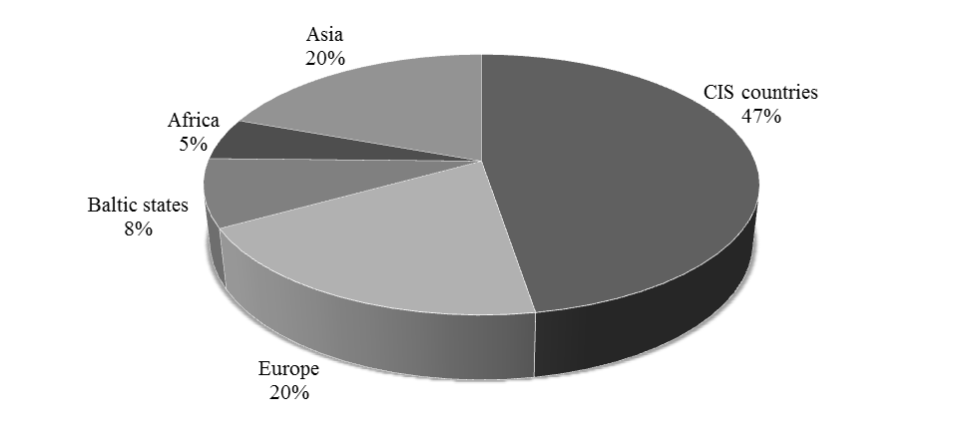
Figure 5 – The universities participation in the exhibitions and fairs
depending on the region for the period 2001-2010
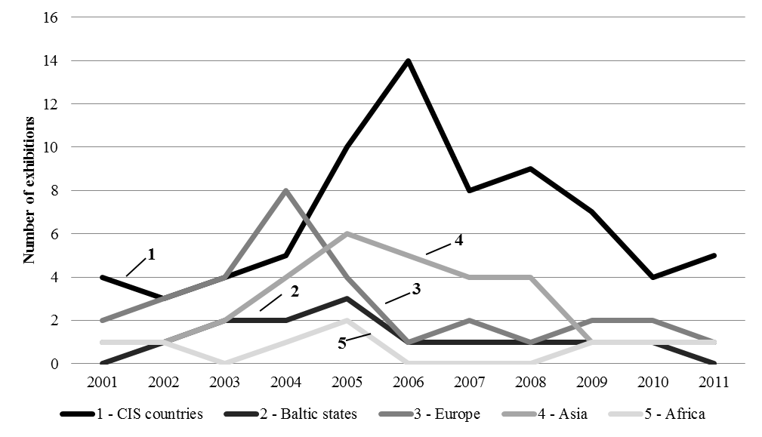
Figure 6 – The universities participation in the exhibitions and fairs
depending on the region for the period 2001-2010
The Innovation Policy Concept determines the most important socio-economic objective – the improvement of the scientific research implementation efficiency in domestic production. Therefore, the regional division of the exhibitions is objective: the leading region is the national market. It should be noted that this is mainly specialized exhibitions. Regular collective stands of the Ministry of Education are represented in the CIS countries and neighboring states as determined by the Belarusian economy focused largely on the countries of the former Soviet Union. The trend over the last decade shows the growth of foreign trade geography. However, the share of the CIS countries in total, though reduced, however, actually has a decisive influence on the processes in Belarus (especially, true for Russia which is one of the major trading partners of the country).
Among the perspective economic partners the Asian region is distinguished (China, Vietnam, Korea) with their huge scientific, technological, investment and human resources and the Baltic countries (Lithuania and Latvia), Poland – facilitated economic cooperation to some extent due to the common border.
A similar geographic image is observed on financial flows. According to Table 1 and Figure 7 the graph shows the proportion of the different regions in the export of the universities for the period 2007-2010. We can say definitely about the priority of any region which indicates multi-vector relations of the organizations and institutions of the MoE: in 2007-2008 – Russia, in 2009 – Asian countries, in 2010 – European countries. Based on the results, in the future we can focus on these regions as the most perspective in terms of potential international contracts.
Table 1 – Exports of high technology products by the universities
№ | Regions | 2007 | 2008 | 2009 | 2010
 | Russia | 754 699 $ | 1 216 423 $ | 714 023 $ | 525 732 $
 | Asia (China, India, Malaysia, North and South Korea, Japan) | 269 787 $ | 230 105$ | 1 057 775 $ | 478 953 $
 | Europe | 324 784 $ | 313 444 $ | 39 600 $ | 769 553 $
 | CIS countries (Kazakhstan, Armenia, Ukraine) | 164 528 $ | 375 473 $ | 141 715 $ | 52 842 $
 | Baltic states | 72 031 $ | 206 622 $ |  | 150 024 $
In total |  | 1 585 829 $ | 2 342 067 $ | 1 953 113 $ | 1 977 104 $
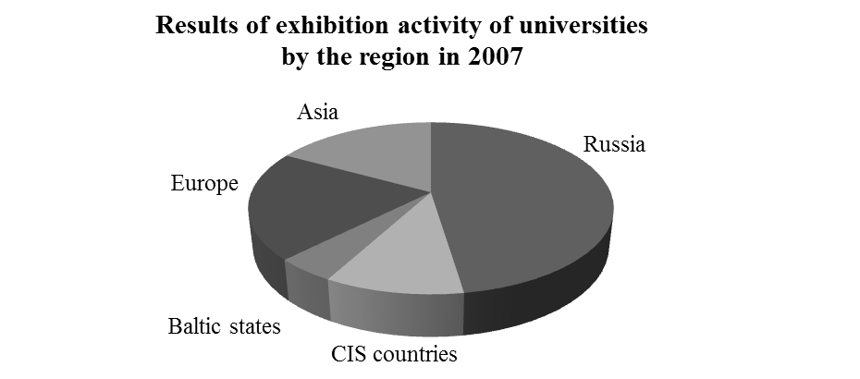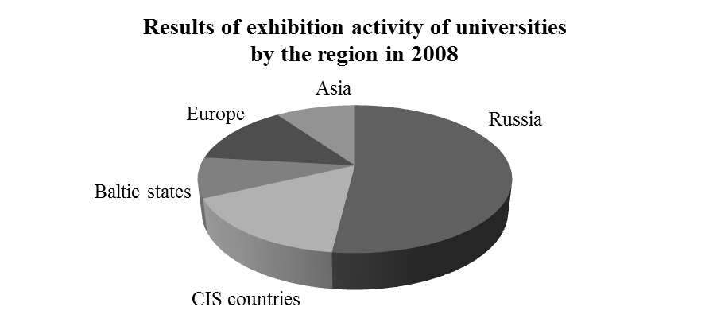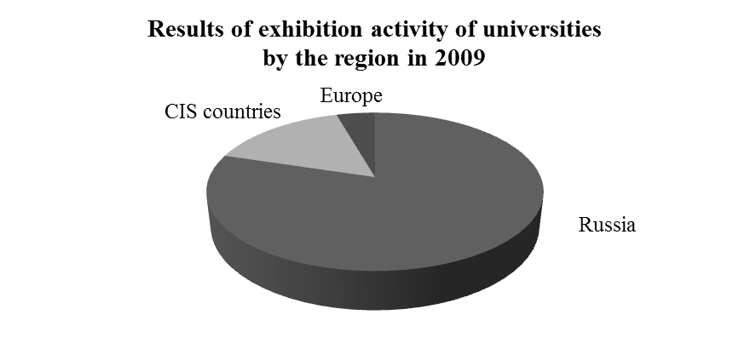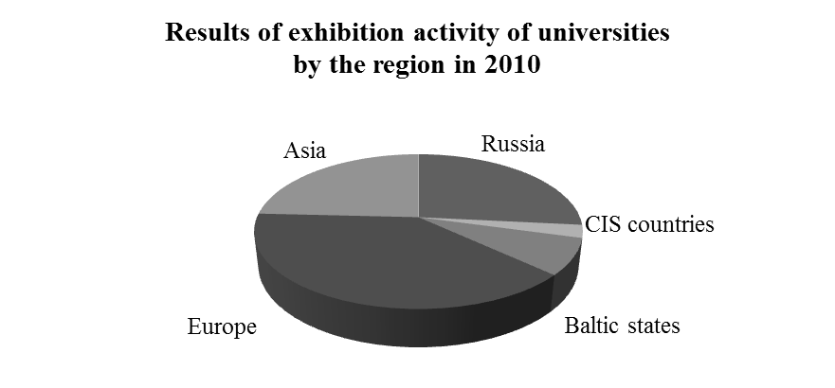
Figure 7 – The results of the exhibition activity of the universities in 2007-2010
Information analysis, conducted by the ICMSRW specialists with experts participation and using the capabilities of the centralized database of marketing information of science and technology products, provides the increase in the efficiency of international exhibitions, the market support of the most competitive development, the identification and support of the perspective areas of the R&D, the active support of the innovation activity and technology transfer in the Republic of Belarus.
The analysis of the results of the universities participation in the international exhibitions shows that among the main objectives for the participants of the Belarusian delegation the following are mainly achieved: introduction the developments to the foreign partners, contracting opportunities evaluation, tying new contacts in the business world, determination the possible demand of the developed products, studying the market conditions in the industry, cooperation development, meetings with the organizations of the host country, monitoring the competitors and comparison our products with the products of competitors, studying other countries' expositions.
The results of the negotiations, as a rule, are in mutual communication, the manifestation of intent on cooperation, agreement for additional information and often limited by the range of problems.
At the present stage the increase in efficiency of the exhibits presentation and, consequently, the growth of exports of high technology and innovative products of the higher education institutions of the Republic of Belarus may be based on information and analytical interaction of the organizations and institutions of the MoE, continuous analysis of their export potential, usage of the advanced IT-technologies. This principle was put into the automated system for monitoring the international exhibition activity of the MoE's organizations and the website http://www.exhibit.metolit.by.
The system is formed as a single information space for the MoE's organizations which is based on a constant information and analytical interaction of the organizations and institutions of the MoE. It is used to find, support and promote the developments, innovative products of the MoE's organizations to the foreign market, to continuous support in the course of the system information and analytical operation, for the optimal operational decision-making.
Organization the participation of the universities, research and innovation organizations of the MoE in the international scientific and technical events is carried out with the export potential analysis in the leading areas of the universities research, also with the search and work with potential customers and partners, with the development of the specific projects to promote the knowledge-intensive export-oriented developments to the foreign markets using the stable system of relations between scientific and innovative institutions of the MoE on the basis of an unified information platform www.exhibit.metolit.by.
On the base of the developed system for monitoring the international exhibition activity the automation of accounting, analysis and use of information about the innovation export potential of the universities for the joint exposition preparation is organized. This provides the highly efficient and professional presentation of the scientific and technical developments, innovative products at the international market, the growth of exports of high-tech products, the information and analytical support to the management of science in high school.
Constant research of the scientific and technical products market which is made by the ICMSRW for over ten years is essential to the development of competitive products. Based on the long-term experience of exhibition preparation, the analysis of the obtained results in the international scientific and technological cooperation, using the resources of the automated monitoring system for the exhibition activity www.exhibit.metolit.by, as well as resources of the information storage and retrieval systems www.icm.by, www. metolit.by, www.imu.metolit.by and the websites of the centers for scientific and technological cooperation, the "Polytechnic" continues to address the issues of developments exhibition, their business improvement and implementation in the certain country, in the certain market, at the certain exhibition. The results of this work are aimed at high-performance and professional presentation of the scientific and technical developments, innovative products and educational services of the institutions of higher education of the MoE of the Republic of Belarus in the international market.
List of references:
1. Самсонова М.В. Особенности формирования рынка научно-технической продукции в современных условиях хозяйствования / М.В. Самсонова // Вестник Оренбургского государственного университета. – 2008. – №11. – С. 114-120.
2. Баринов С.Б. Выставочная деятельность как способ позиционирования на рынке [Электронный ресурс] // Корпоративный менеджмент: [сайт]. – СПб, 2008. – URL: http://www.marketing.spb.ru/lib-research/segment/exhibition.htm.

