Innovation Clusters of Grodno Region: Structure and Operating Experiences
V. Struk, O. Avdeichik, E. Ovchinnikov, V. Kravchenko
Yanka Kupala State University of Grodno
e-mail: proffi2011@rambler.ru

The most effective concepts for the world economy in the progressing globalization include clustering, involves the formation of vertical and horizontal linkages of informal associations of economic entities at the regional, inter-regional, national and supra-national levels [1, 2]. It is considered [1] that clustering is a good opportunity to use the full potential of all participants in the life cycle of industrial products, the role of which is enhanced by the innovative strategy of functioning economic system, which is no alternative towards sustainable development of the world economy.
Enough free interpretation in the literature [1-7] the term "cluster" and a large number of its semantic analogues treats the cluster structure of various production and business systems - from traditional research and production associations and industrial areas [1] to the scientific and technical centers and cluster of institutions. [1]
Formalized by the term excludes the characteristics of these structures, so the types of educational and scientific institutions are clusters formed in functions of teaching or research units. However, such a simplistic understanding of the cluster structure does not fully conform to modern ideas about the features of the formation and functioning of formal and informal associations, intended for implementation of optimized business process.
In the last decade, the term "cluster" includes the characteristics of the innovative structure providing optimal conditions for the development of innovations for various purposes, the production and sale of innovations according to the stages of the life cycle of industrial products [2, 3]. An obvious consequence of the development of clusters is mainly an innovation-oriented progressive development of the industrial structure. Moreover, the prerequisites for the creation of such clusters are innovations that contribute to the achievement of the economic subject socio-economic impact of high level.
Methodology of formation and functioning of various types of industrial clusters in sufficient detail considered in a number of studies [1, 2, 7]. However, analysis of the literature demonstrates the need for system development process to ensure the problem of intellectual functioning of innovative industrial clusters.
It seems to us that one of the fruitful conceptual approaches to the methodology of innovation clusters is integration, involving logical and functional relationship of the scientific component of all cluster components in the stage of innovation personnel with increased creativity and targeted training. [2]
Creative use of theoretical development of cluster approaches in different fields of human activity, allowed to implement the integration principle in the formation of innovation cluster structures like the Training Center (EMC) with elements of scientific and research (RS), educational (ES), organizational functions on a uniform basis - the informal use of the union personnel, technological, scientific, research and institutional capacity of the leading regional industrial plant (IP), the university and academic institutions [2] (Figure 1).

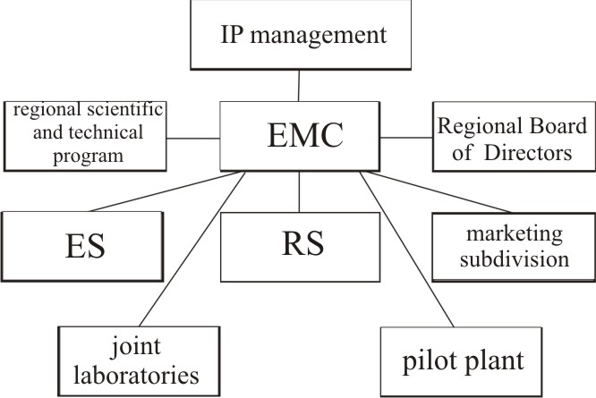
Figure 1. The principle structure of the integration of the cluster [2]

The educational methodological center "Promagromash" over the years contributes to the concept of regional development in the region through training of engineers, including highly qualified personnel for industry Grodno region, development and protection of functional innovations in the form of new materials, technologies, designs, support the process of industrial use, the publication of textbooks, teaching aids in the disciplines of engineering education and monographs on materials science and technology to engineering, information, advertising and exhibition activities at the scientific, technical and commercial events (conferences, workshops, fairs, exhibitions).
The major structural components of the scientific cluster EMC "Promagromash" are branches specialized academic departments and a network of joint research laboratories that operate on the leading industrial enterprises of the region.
The experience of forming the integration of scientific cluster demonstrates the need to improve its organizational structure by creating information-analytical, manufacturing and regulatory divisions focused on solving economic, social and political problems of Grodno region.

References:
1. Yasheva, G.A. The cluster approach to improve the competitiveness of enterprises. - Vitebsk, UO VGTU. - 2007. - 301 p.
2. Intelligent innovating industry: technical, economic and methodological aspects. O.V. Avdeichik and [others] ed. V.A. Struk, L.N. Nekhorosheva. Pl.: Law and Economics, 2007. - 523 p.
3. Bovin, A. Managing Innovation in the organization: a manual / A.A. Bovin, L.E. Cherednikova, V.A. Yakimovich. - Omega-L, 2006. - 415 p.
4. Bogdan I.I. Regional innovation policy. Novopolotsk: PSU, 2000. - 358 p.
5. Asaul, V.V. Scientific basis of the innovative development of the area through the creation of special economic zones. - Saint-Petersburg.: Nauka, 2006. - 217 p.
6. Problem of transitive economy: innovation, stability, globalization: Proceedings of International. scientific and practical. Conf. / Red. coll., ed. Ed. V.N. Shimov. - Mn.: BSEU 2007. - 555 p.
7. Innovation Management in Russia: strategic management and scientific and technological security / V.A. Makarov, A. Varshavsky. - Moscow: Nauka, 2004. - 880 p.

