Operated Intrapipe Sealing Device for Oil Pipelines
Y. Kryshneu, S. Kukharenka, L. Zakharanka, V. Starastenka, A. Sakharuk, M. Stalbou
Pavel Sukhoi State Technical University of Gomel,
U. Jakavets, U. Varabiou
JSC «Gomeltransoil Druzhba»
e-mail: kyuri73@tut.by

1. Assignment
Capping of certain leases of oil mains by the means of remote control for the purpose of localization of defective sites of the oil pipeline for its subsequent repair.

2. An operating principle
The operated intrapipe sealing device (ISD) migrates through the oil pipeline at the expense of energy of the environment, i.e. together with the cargo oil. The operating principle of the sealing device after launching consists in the following. On command from the ground-level device the valve opens by the means of electric drive, and the internal hydraulic cylinder starts to be spacefilled by the oil intensively. The polyurethane pump buckets laid out on the exterior diameter of the sealing device, together with a gauging rod migrate under the influence of an oil-column pressure up to mechanical fixation of the whole sealing device at the expense of friction of the shifted pump buckets with the internal walls of the pipeline. After that the sealing device retains hydrostatic pressure of a column of oil for the period of conducting a repair work, preventing an oil spill, environmental pollution and potentially fire-dangerous situation. After the end of repair works a command from the ground-level device to close the valve is given (by the means of electric drive reverse), the pressure of the pump buckets of the ISD on the pipe walls reduces, then the pressure in the oil pipeline raises, and the ISD from the fixation site is transported by oil to the reception camera.

3. A construction
ISD (fig. 1) consists of: a mechanical stopper (MS), the intrapipe device (ID), the sensor of rod movement (SRM) and the electrically-actuated valve (EAV).
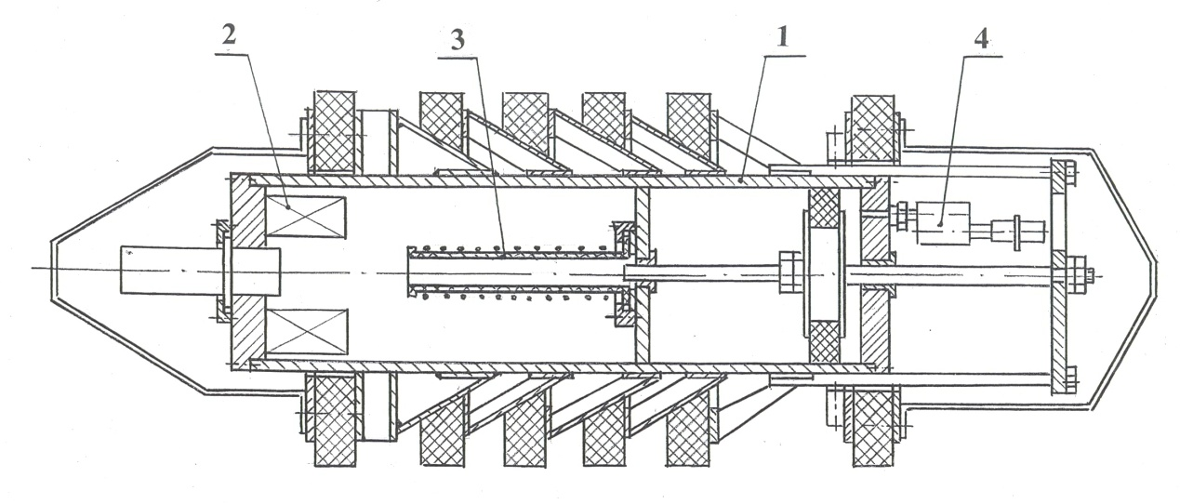
Fig. 1. Schematics of the operated intrapipe sealing device: 1 – MS,
2 – ID, 3 – SRM, 4 –EAV.

The mechanical stopper, in its turn, includes a shell, tapered rails, sealing pump buckets, a hydraulic cylinder, a gauging rod, a front flange with cases for the electronic intrapipe device.

4. Technical advantages
The advantages of the operated intrapipe sealing device in comparison with the standard construction sealing device, currently applied on "Druzhba" oil pipeline, are the following.
1. The enhanced radius of acquisition (up to 11m).
2. Triggering the process of hermetic sealing by the means of remote control of the valve electric drive of the ISD from the ground-level device, without advance raising of the pipeline pressure, indispensable for breaking a membrane in case of a nonsteerable induction valve.
3. Continuous monitoring of the position of gauging rod
(and, hence, the pump buckets of the sealing device) in the course of hermetic sealing.
4. Capability to close the ISD’s valve with the help of engine reverse of the electric drive for simplification of withdrawal the ISD from the oil pipeline after the end of repair works. For this purpose the rod is constructed with a smooth surface, without a mechanical lock of the final position that allows the pump buckets to be shifted not only forward (at the initial valve opening), but also backward, at pushing the sealing device through the pipeline for its withdrawal from the special reception camera after the end of repair works.
A special testing chamber for conducting of trials under operating pressure is designed and produced at the oil pumping station "Gomel" of the JSC «Gomeltransoil Druzhba».

REFERENCES

1. Крышнеў Ю.В., Кухарэнка С.М., Якавец У.Д., Вараб’ёў У.У., Старасценка В.А., Захаранка Л.А., Сахарук А.У., Сталбоў М.В. Электрамеханічны модуль кіруемага герметызатара для магістральных нафтаправодаў / Надежность и безопасность магистрального трубопроводного транспорта: сб. науч. тр. / Полоц. гос. ун-т; под общ. ред.д-ра техн. наук, проф. В. К. Липского. – Новополоцк, 2011. – С. 144-151.
2. Крышнеў Ю.В., Гарбуз В.М., Старасценка В.А., Кухарэнка С.М., Захаранка Л.А., Вінаградаў Э.М., Сахарук А.У., Сталбоў М.В., Лукашоў В.М. Праектаванне бесправаднога канала сувязі для кіравання клапанам кіруемага ўнутрытрубнага герметызатара / Вестник УО «ГГТУ им. П.О. Сухого». – 2012. – № 1.– С. 29-34.

