The Sol-Gel Films Application for the Development of Energy Efficient Innovative Technology
V. Gaishun, Y. Kosenok, D. Kovalenko, A. Semchenko, V. Sidsky, V. Vaskevich, O. Tyulenkova
F. Scorina Gomel State University
e-mail: vgaishun@gsu.by

Introduction
Sol - gel process in comparison with traditional methods of deriving of vitreous structures has unique advantage: it allows preparing for the same composition, such as silicon oxide, as considerably distinguished shapes - fibrils, films, monoliths, xerogels, aerogels by changing only some experimental conditions. Parameter of processing which needs to be drive, viscosity, pH of sol and concentration of oxides which should be in fixed limits
Distinctivenesses sol - gel of production engineering in comparison with traditional methods of forming of composite materials are:
- High chemical homogeneity and purity component, containing in a final material on a molecular scale;
- Pliability and controllability of process;
- Forming of silicate and ceramic matrixes at lower temperatures;
- The high reactive capacity of porous xerogels and subsequent them solid; phase transferring in glass or an aerogel, without of a stage of a melting, allows to gain the broad audience of chemical combinations.
Sol-gel technology is very simply, cheep, ecologically. For example, this methods yields high-purity and activated silica glasses for optics, optoelectronics and laser optics at lower temperatures eliminating the fusion stage. The sol-gel transition occurs due to polycondensation, hydrolysis, gel formation followed by heat treatment producing dense gels. Unlike fused glasses, gel ones contain less impurities that results from the quality of initial materials. They also have a lower synthesis temperature. The sol-gel technology is believed as energy and resource saving process. Is one more advantage is the simplicity of necessary equipment [1].
Colored silica sol-gel films on soda-lime glasses and plastic substrates
Glass tiles are generally used for decoration purposes. There are two types of sol-gel coatings: inorganic and hybrid inorganic-organic ones. Especially, when the safety regulation matters, the inorganic sol-gel coatings are useful. The inorganic sol-gel coatings which are based mostly on metal oxides result in minimum harmful fumes under fire. Inorganic sol-gel coatings in building industry like glass tiles are developed in many countries [2].
Hybrid coatings would have both the advantages from inorganic-organic materials. In this work, we present the films doped with organic dyes (rhodamine, coumarine, nigrosine, methylene blue) and metal (Fe, Co, Fe-Co) oxides [2]. Thickness of these films synthesized on plastic substrates at temperatures 100-150⁰С and soda-lime glasses at 500 ⁰C was 0.2-5 μm. The films possess good adhesive properties and high stability with respect to mechanical attrition those fit the industry standards. The refraction index and factor of dispersion are the same as for conventional silica films. Absorption bands in the visible can be varied depending on type and concentration of organic dyes (Fig. 1) or inorganic dopants (Fig. 2).
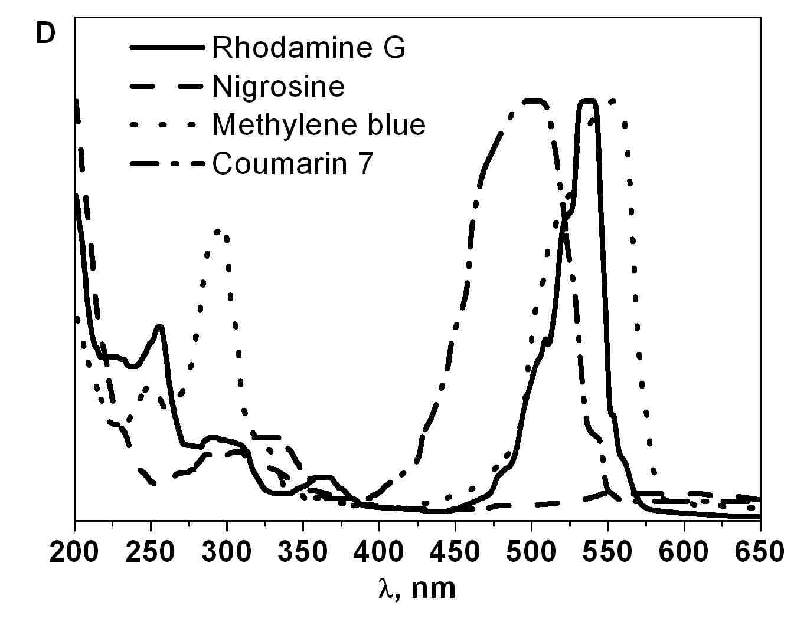

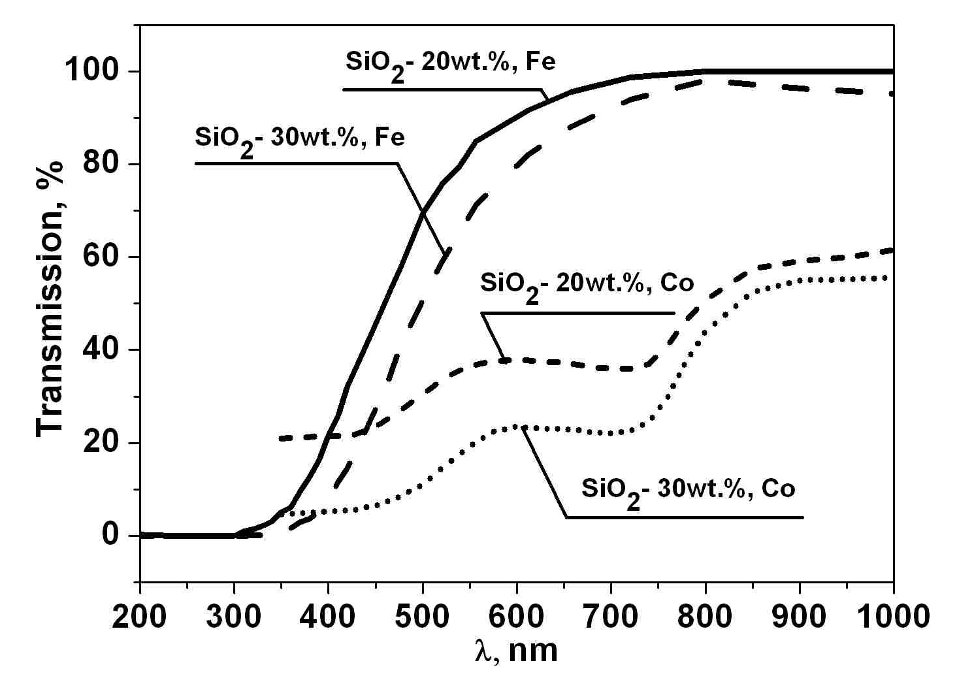

Fig. 1. Absorption spectra of silica sol-gel films doped with organic dyes

Fig. 2. Transmission spectra of silica sol-gel films doped with metal oxides.

Rust-proofing inorganic covers
By the sol-gel technique we have developed the technology to produce protective and rust-proofing inorganic silica covers on the metal surface. Precursor solutions for film-forming solution will be prepared by hydrolyse of silicon organic compound. That is conventional procedure used for silica sol-gel films. films are produced by spin- or dip-coating on a substrate at room temperature. Then films are heated at 400 ⁰C in air.
Advantages of protective and rust-proofing covers on the metal surfaces:
1. Resistant to against mechanical attrition the coat is formed at temperature 400 ⁰C on air.
2. Inductivity quantity – 10.5-8.4.
3. Mechanical stability to a temperature cycling up to T = 700 ⁰C.
4. Humidity and corrosion resistance in aggressive lead-acid and an alkaline condition.
At temperature of aggressive medium up to 50 ⁰C
Conclusions
Sol-gel method offers the advantage of a relatively simple production procedure of the vitreous material. This method is known to produce materials from solutions either in bulk, coating, films, fibers or powders. Silica sol-gel materials are characterized by the lowered maintenance of the impurity, the caused cleanliness of initial materials, and low temperature of synthesis; besides a sol-gel method gives more ample opportunities of influence on physical and chemical parameters of final products.
Sol-gel technology is resource- and energy-saving, allows receiving ready products or perform with form and sizes to finished articles (rational preparations) with the big percent of an output suitable and small quantity of waste products. Its advantage is also simplicity of the used equipment.

- C.J. Brinker and G.W. Scherer, Sol-Gel Science: The Physics and Chemistry if Sol-Gel Processing (Academic, New York, 1990)
- Synthesis of RE-Ag, Al-Re-doped sol-gel glass and films for solar cells/A.V. Semchenko [et. al.]// J. of Rare Eearth, Vol. 27, № 4, Aug.2009, p. 671-674

